Permaculture Design Certificate (PDC)  April 24-May 8, 2016 | Saidoun - Jezzine (South Lebanon) |  |  |  |  |  |  |  |  | 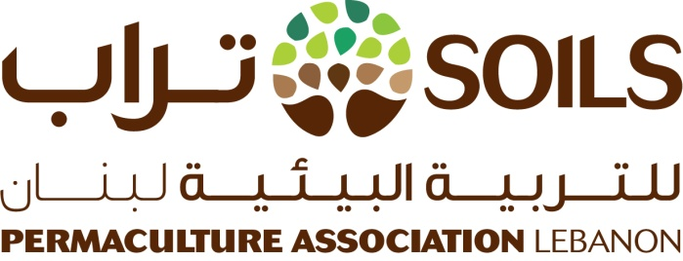
REGISTRATION FORM
Please fill the form below and send it by email to contact.soilslebanon@gmail.com by April 4, 2016 at the latest
*All fields are required - Write N/A where the information is not applicable)
PERSONAL INFORMATION
1. First name: |  |  |  |  |  |  |  | 3. Date of birth (DD/MM/YYYY)
2. Last name: |  |  |  |  |  |  |  | 4. Gender (Male/Female)
CONTACT DETAILS |  |  |  |  |  |  |  | ADDRESS
5. Mobile |  |  |  |  |  |  |  | 8. Caza
6. Landline |  |  |  |  |  |  |  | 9. City or Village
7. Email |  |  |  |  |  |  |  | 10. Street
EDUCATIONAL/PROFESSIONAL BACKGROUND
11. Current occupation (if applicable)
12. Highest level of education
13. Are you currently a student? (YES/NO)
If YES, please specify:
14. University |  |  |  |  |  |  |  |  | 15. Major
FOOD/SAFETY INFORMATION
16. Do you have specific diet needs or restrictions? (YES/NO)
If YES, please specify (vegan, vegetarian, gluten-free, etc.)
17. Do you suffer from any allergies/chronic conditions? (YES/NO)
If YES, please list your medication(s) and dosage
IN CASE OF EMERGENCY, WHOM SHOULD WE CONTACT?
18. Emergency contact name |  |  |  |  |  |  | 19. Emergency contact tel.
ADDITIONAL INFORMATION
20. How did you hear about the Permaculture Design Certificate (PDC)?
21. What do you hope to learn from this course?
22. List any skills/talents you have that could be related to permaculture (agriculture, farming, building, art, etc.)
See Page 2 for fees and registration

Page 1/2
PARTICIPATION FEES
Fees include tuition costs, accommodation for the duration of the course and meals.

The number of participants is limited:
To confirm your place, you need to pay the pre-registration fee (non-refundable) by April 4, 2016 at the latest
Lebanese nationals | $650 per person ($250 pre-registration by April 4, 2016 + $400 on the first day of the PDC)
Non-Lebanese residents | $650 per person ($250 pre-registration by April 4, 2016 + $400 on the first day of the PDC)
The second part of the payment is due by the first day of the course (April 24) at the latest

* Early Bird Discount: $590 for early registration (full payment by March 10, 2016)
International participants | $1,200 per person
* Early Bird Discount: $1,000 for early registration (full payment by March 10, 2016)
PAYMENT METHOD
Local participants (Lebanese and non-Lebanese residents): Cash or Money Transfer (OMT)
Contact us to arrange for a transfer via OMT or set up a face-to-face meeting at your convenience in or around Beirut.

Email contact.soilslebanon@gmail.com or call +961-71-617988

We will also announce open info-sessions in Beirut to answer your questions one-on-one and/or accept your payment
Stay tuned to our Facebook page to find out more.
International participants: Money transfer
Contact us to discuss the most convenient payment method
REGISTRATION
The deadline for registration is April 4, 2016.

Please send this completed form by email to contact.soilslebanon@gmail.com and pay the pre-registration fee by April 4, 2016 at the latest

Do you have any comments, questions or anything else you'd like to share with us?

For further questions and details, please email us: contact.soilslebanon@gmail.com or call +961-71-617988

DISCLAIMER
I, the undersigned certify that the information I have provided in this form is complete and accurate. I agree to take full responsibility for all my personal belongings and valuables. I understand that SOILS Permaculture Association Lebanon will not be held liable for any personal injury/affliction resulting from information I withheld from the association, and/or for any damage/loss to my property.

Date |  | Signature
 |  | (leave blank for now)

Website: www.soilspermacultureassociationlebanon. com
Email: contact.soilslebanon@gmail.com
Facebook: SOILS Permaculture Association Lebanon

Page 2/2

